PRIMARY MARKET

PRIMARY MARKET:

* Provides channel for sales of new securities
* Provides opportunities for issuers
* Face value or discount
* Domestic or international market

Face value:

* The nominal or stated amount assigned to security by an issuer
* Also known as par value or simply par
* For an equity share, the face value is small
* In debt share, the face value amount is repaid when the bond matures

Premium or Discount:

Premium > face value

Discount < face value

Mostly premium, rarely discount

**Why do companies need to issue shares to the public?**

* Money from banks and financial institutions may not be sufficient
* So public is invited to contribute towards equity shares and issue shares to individual investors
* It’s called public issue
* SEBI lays rules and regulations

TYPES OF ISSUES:

* Public issue
* Rights issue
* Preferential issue

Public issue:

* The issues to float a new company or to expand a existing company. New public issues are done in form of IPO or FPO

Rights issue:

* There are issues of fresh securities to the existing share holders
* This is best for the companies who would like to raise capital without diluting the stake

Preferential issue:

* These are issues done privately but not through public offering

Tary 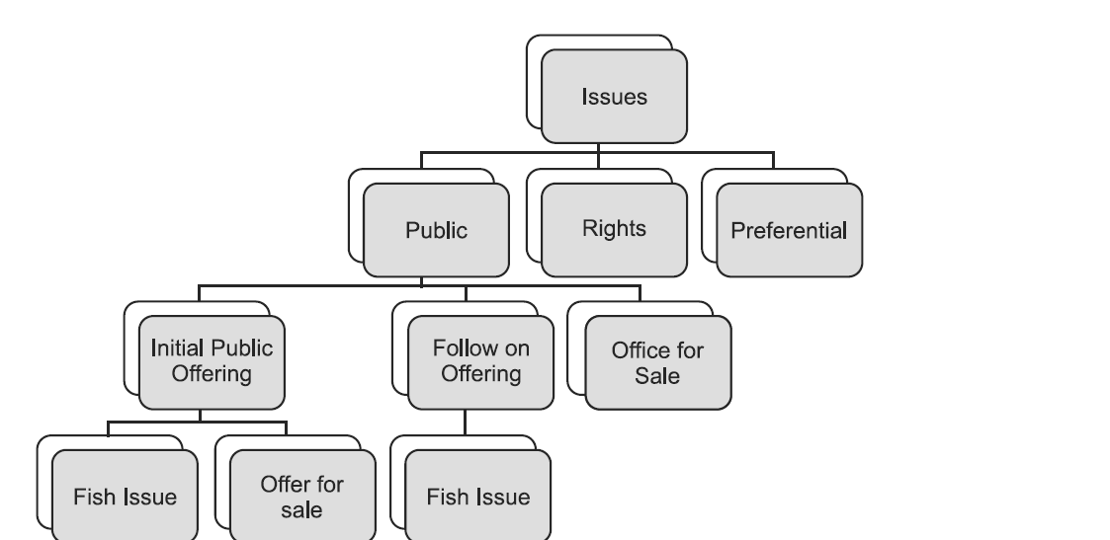

IMPORTANT PARTIES:

1. Underwriter:

Underwriter gives an assurance to the issuer that they will subscribe to the securities offered in the event of non-subscription by the parties to whom they are offered

1. Bankers:

They are responsible for collecting application money along with the application

1. Financial institutions:

Extend term loans of a company

1. Government and statutory bodies

ISSUE PRICE:

* Shares offered initially in the primary market
* MP is above or below issue price
* NSE website is useful to check about the MP

MARKET CAPITALIZATION:

Market value = Current share price * number of shares

IPO:

Company makes either a fresh issue or offers sale on existing security for first time

* It happens when unlisted company makes either a fresh issue of securities or an offer for sale of its existing securities or both for first time
* The share can be through book building or normal

BOOK BUILDING

Min< <Max

Floor price< <Selling price

Floor – 20% - cap

1. Choosing an investment banker
2. Launching the shares
3. Finalizing the total pricing shares
4. Publicizing
5. Allotment and settlement

Who?

* Issuer in consultation with merchant banker shall decide the price
* Parameters are important

|  |  |
| --- | --- |
| BOOKBUILDING | PUBLIC ISSUE |
| 1.Price not known | 1.Price known |
| 2.Demand can be known | 2.Demand is known at close of issue |

CUTOFF PRICE:

Issue price is called cut off price.

Price band can be revised through

* Inform stock exchange
* Press release
* Website

Bidding period is extended till 3 days (not more than 10 days)

OPEN OUTCRY SYSTEM:

* Communication between professionals of stock exchange on trading floor
* Use of hand signals and shouting
* Buy and sell orders
* Trading floor is called pit
* Best price

1. Over the counter
2. Telephone trading
3. Electronic trading (faster, cheaper and more efficient)
4. Book building

How does one know if shares are allotted in an IPO/offer for sale? What is the timeframe for getting refund if shares not allotted?

* Basis of allotment should be completed in 4 days from the issue close date
* Within a working day, the detail of credit to demat account/allotment advice and dispatch of refund orders need to be completed
* So an investor should know in about 5 working days’ time from the closure of issue, whether shares are allotted to him or not.

ASBA

* In general IPO process
* Application money is payed upfront
* Investor losses interest
* Company pays interest on delay of refund
* In order to prevent this ASBA is introduced

ASBA: App Supported by Blocked Amount

* Block money in bank account, for subscribing to an issue
* Investors money shall be debited only if his/her allotment is withdrawn or selected
* Investor can apply to any public or rights issue
* ASBA acts as SCSB
* After filling form, the money is blocked
* From 1ST JAN 2016 public issues are subscribed only through ASBA
* 6 working days

SCSB:

* SCSB is a bank through which the applicant can make an ASBA request
* Apply to SEBI to work as SCSB
* Identifying designated branches
* Identifying controlling branches

WHO can act as investors?

* Is a “resident retail individual investor”
* Is bidding at cut off price
* Applying through blocking of funds
* Has agreed not to revise his bid
* Is not bidding under any reserved category

REGISTRAR:

* Finalizes the list of eligible allotters
* Ensures crediting of shares
* Dispatch of refund orders
* Lead manager coordinates with registrar
* NSE provides access in remote areas
* NEAT IPO fully automated screen-based bidding system

Book Building through the NSE system offers several advantages:

* The NSE system offers a nationwide bidding facility in securities
* It provides a fair, efficient & transparent method for collecting bids using the latest electronic trading systems
* Costs involved in the issue are far less than those in a normal IPO
* The system reduces the time taken for completion of the issue process
* The IPO market timings are from 10.00 a.m. to 5.00 p.m.

PROSPECTUS:

* Large companies float public issues
* Some are genuine, while some are exploit
* Guidelines by SEBI is a disclosure to public
* Disclosure includes info like
* Raising of money
* Money to be sent
* Return
* This info is in the form of prospectus
* Size of issue
* Current status of company
* Equity capital
* Underwriting
* Statutory companies

OFFER DOCUMENT

* Public issue- prospectus
* Rights issue – letter of offer

is filed with the Registrar of Companies (ROC) and Stock Exchanges (SEs). An offer document covers all the relevant information to help an investor to make his/her investment decision.

DRAFT OFFER DOCUMENT

* Offer document is at draft stage
* SEBI issues 30 days before the registration of red herring prospectus
* SEBI can specify changes if any
* Draft offer document is available on website for 21 days

Red Herring Prospectus is a prospectus, which does not have details of either price or number of shares being offered, or the amount of issue. This means that in case price is not disclosed, the number of shares and the upper and lower price bands are disclosed.

ABRIDGED PROSPECTUS:

‘Abridged Prospectus’ is a shorter version of the Prospectus and contains all the salient features of a Prospectus. It accompanies the application form of public issues.

Who prepares prospectus?

Merchant bankers finalize the:

* Cost
* Profitability estimates
* Preparing prospectus

LOCK-IN:

* Freeze on sale of shares
* Min percentage

LISTING OF SECURITIES:

Formal agreement to deal with stock exchange of securities.

* To provide liquidity and marketability
* Listed securities are traded where they are listed on stock exchange.
* Listed ceremony is opened after allotment where the shares are open for trading
* TYPES:
* Initial
* Public
* Rights
* Bonus shares
* Amalgamation
* DOCUMENTS REQUIRED
* Prospectus
* Agreement with underwriters
* Details of capital structure
* Ads
* Financial statements
* Letter of allotment
* Details of company
* Shares and debentures
* Brokerage etc.,

DELISTING:

Permanent removal of securities

SEBI’S ROLE:

* Any company making issue of value more than 50 lakhs is required to file an offer document
* Validity period for letter is 3 months
* SEBI does not recommend issue or takes responsibility
* It scrutinizes the issue
* SEBI does not associate itself with any issue

FOREIGN CAPITAL ISSUANCE

Indian companies are permitted to raise foreign currency

1. issue of foreign currency convertible bonds more commonly known as FCCBs
2. issue of ordinary shares through depository receipts namely ‘Global Depository Receipts 20 (GDRs)/American Depository Receipts (ADRs)’ to foreign investors i.e. to the institutional investors or individual investors

ADR (American Depository Receipts)

Physical certificate evidencing the ownership of ADS’s.

ADS:

* US dollars denominated form of equity ownership in non US companies.
* It represents foreign shares of company held on deposit by a custodian bank
* One of the several ADS can be represented by a physical ADR certificate

GLOBAL DEPOSITORY RECEIPTS

* Global Depository Receipts (GDRs) may be defined as a global finance vehicle that allows an issuer to raise capital simultaneously in two or markets through a global offering
* GDRs may be used in public or private markets inside or outside the US
* GDR, a negotiable certificate usually represents company’s traded equity/debt

FOREIGN CURRENCY CONVERTIBLE BONDS:

* Foreign Currency Convertible Bond’ (FCCB) means a bond issued by an Indian company expressed in foreign currency, and the principal and interest in respect of which is payable in foreign currency’
* These are bonds that are convertible to equity after a certain period of time at the option of the bond holder
* These are issued in the international markets by Indian companies.

CONCLUSION:

Primary markets are markets for first issue of securities. Primary issues can be either public issues or private placements. The price of issues can be either fixed or found out through book building. The chief intermediaries in primary markets are the merchant bankers who lead the company through public issues. SEBI also allows foreign issuances by way of American and Global Depository Receipts and Foreign Currency Convertible Bonds. Public issues are monitored by SEBI and made through issue of prospectus. Once the issue is completed, the securities are listed on a stock exchange